**DAY-3**

1.Write a program to perform the following:

o An empty list

o A list with one element

o A list with all identical elements

o A list with negative numbers

**program:-**

l = [-9,-10,1,3,0]

n = len(l)

for i in range(n):

    for j in range(0,n-i-1):

        if(l[i]>l[i+1]):

            l[i],l[i+1] = l[i+1],l[i]

print(l)

**output:-**

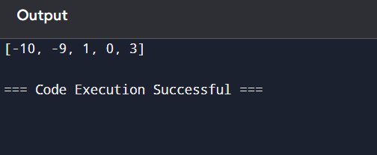

2.Describe the Selection Sort algorithm's process of sorting an array. Selection Sort works by dividing the array into a sorted and an unsorted region. Initially, the sorted region is empty, and the unsorted region contains all elements. The algorithm repeatedly selects the smallest element from the unsorted region and swaps it with the leftmost unsorted element, then moves the boundary of the sorted region one element to the right. Explain why Selection Sort is simple to understand and implement but is inefficient for large datasets. Provide examples to illustrate step-by-step how Selection Sort rearranges the elements into ascending order, ensuring clarity in your explanation of the algorithm's mechanics and effectiveness.

**Program:-**

array = [5, 2, 9, 1, 5, 6]

n = len(array)

for i in range(n):

    min_index = i

    for j in range(i + 1, n):

        if array[j] < array[min_index]:

            min_index = j

    array[i], array[min_index] = array[min_index], array[i]

print(array)

**output:-**

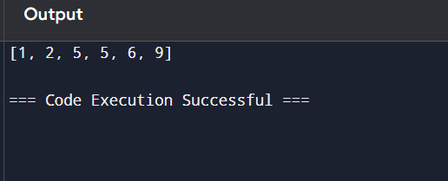

3.Write code to modify bubble_sort function to stop early if the list becomes sorted before all passes are completed.

**Program:-**

# Input list

arr = [64, 25, 12, 22, 11]

# Length of the array

n = len(arr)

# Optimized Bubble Sort

for i in range(n):

    swapped = False  # Flag to detect if any swapping happens

    for j in range(0, n - i - 1):

        if arr[j] > arr[j + 1]:

            # Swap if the element found is greater

            arr[j], arr[j + 1] = arr[j + 1], arr[j]

            swapped = True

    if not swapped:

        break

print(arr)

**output:-**

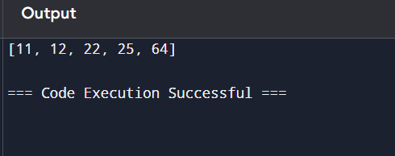

4.Write code for Insertion Sort that manages arrays with duplicate elements during the sorting process. Ensure the algorithm's behavior when encountering duplicate values, including whether it preserves the relative order of duplicates and how it affects the overall sorting outcome.

**Program:-**

arr = [3, 1, 4, 1, 5, 9, 2, 6, 5, 3]

n = len(arr)

for i in range(1, n):

    key = arr[i]

    j = i - 1

    while j >= 0 and arr[j] > key:

        arr[j + 1] = arr[j]

        j -= 1

    arr[j + 1] = key

print(arr)

**output:-**

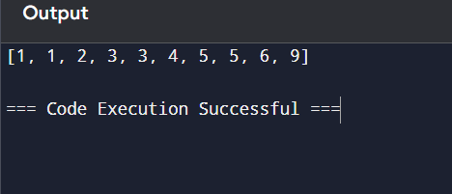

5.Given an array arr of positive integers sorted in a strictly increasing order, and an integer k. return the kth positive integer that is missing from this array.

Example 1:

Input: arr = [2,3,4,7,11], k = 5

Output: 9

**Program:-**

arr = [2, 3, 4, 7, 11]

k = 5

missing_count = 0

current = 1

index = 0

while missing_count < k:

    if index < len(arr) and arr[index] == current:

        index += 1

    else:

        missing_count += 1

        if missing_count == k:

            result = current

    current += 1

print(result)

**output:-**

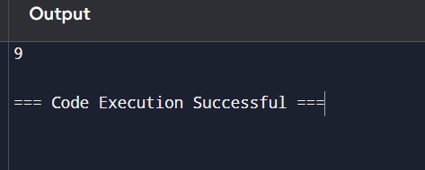

6.A peak element is an element that is strictly greater than its neighbors. Given a 0-indexed integer array nums, find a peak element, and return its index. If the array contains multiple peaks, return the index to any of the peaks. You may imagine that nums[-1] = nums[n] = -∞. In other words, an element is always considered to be strictly greater than a neighbor that is outside the array. You must write an algorithm that runs in O(log n) time.

Example 1:

Input: nums = [1,2,3,1]

Output: 2

**Program:-**

nums = [1, 2, 3, 1]

n = len(nums)

left, right = 0, n - 1

while left < right:

    mid = (left + right) // 2

    if nums[mid] < nums[mid + 1]:

        left = mid + 1

    else:

        right = mid

peak_index = left

print(peak_index)

**output:-**

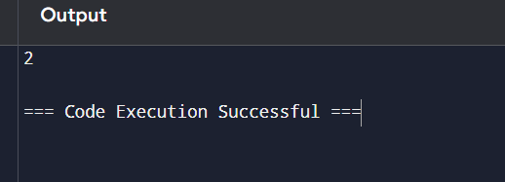

7.Given two strings needle and haystack, return the index of the first occurrence of needle in haystack, or -1 if needle is not part of haystack.

Example 1:

Input: haystack = "sadbutsad", needle = "sad"

Output: 0

**Program:-**

def aravind(haystack,needle):

    if needle=="":

        return 0

    if needle in haystack:

        return haystack.index(needle)

    else:

        return -1

haystack="butsadcalm"

needle="sad"

print(aravind(haystack,needle))

**output:-**

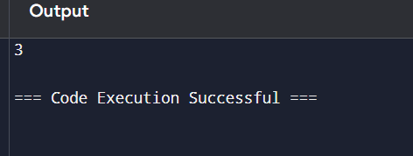

8.Given an array of string words, return all strings in words that is a substring of another word. You can return the answer in any order. A substring is a contiguous sequence of characters within a string

Example 1:

Input: words = ["mass","as","hero","superhero"]

Output: ["as","hero"]

**Program:-**

# Input array of words

words = ["mass", "as", "hero", "superhero"]

# Initialize a set to store the result

result = set()

# Check each word against every other word

for i in range(len(words)):

    for j in range(len(words)):

        if i != j and words[i] in words[j]:

            result.add(words[i])

result_list = list(result)

print(result_list)  # Output: ["as", "hero"]

**output:-**

